一、概述/Scope
璐然包装机械厂是专业生产胶水的生产厂，主要产品有LR-21型胶水机、HD-36型胶水机、HD-38型胶水机、JS-48型裱坑机、JS-55型裱坑机、JS-78型裱坑机、CK-400型冲孔机、CK-600型冲孔机、压纹机、压平机等产品。
Luran equipment plant is professional manufacturer to make the glue-coating machine, our products include LR-21/HD-36/HD-38 and JS-48/JS-55/JS-78 glue-coating machine, CK-400/CK-600 punching machine, and flatting machine, etc.
压平机是一种主要用于对薄纸、皮革、瓦楞纸过胶水后压平的专用设备。
Flatting machine is special equipment for flatting the paper after coating glue.
机本器传动部位采用滚动轴承、链轮、链条和减速箱。上压轴全包胶，下压轴镀硬铬。本机器适用不同厚度的纸张压平。因此使其外型精巧，性能稳定，传动灵敏，噪音小，生产效率高劳动强度低等优点。
The machine uses rolling bearing, wheel, chain and reduction gear box for transfer motion. Up axle is glued, down axle is Cr-plated. This machine is fit of different thickness paper. It has advantages of good looking, stable running, fast response, low noise, and high efficiency.

- 结构及原理/Structure and Theory
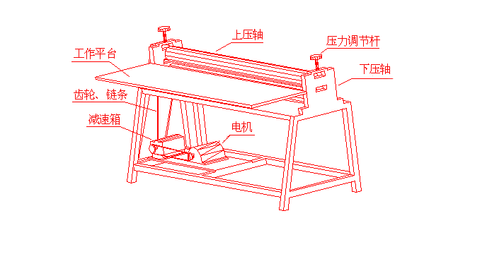 本机器由上下压轴、上下机架、链轮组、链条、皮带、皮带轮、减速箱、电机、调节手轮等部件组成。
This machine is made of up/down two axles, up/down two shelves, gear group, wheel, chain, belt, reduction gear box, engine and adjust handle.
本机由电机驱动，通过三角带轮、三角皮带、减速箱、链条、链轮组等，使上下压轴转动，调节压力调节杆，使上下压轴的间距改变，使上下压轴的压力符合使用要求。
This machine uses engine to provide power, through wheel, belt and reduction gear box to run the two axles. By adjusting the pressure handle, the gap between the two axles can be changed, then make the pressure of the axles to match the requirement.

三、使用说明/Operation Specification
- 使用机器前切记先加润滑油，并使机器保持良好的润滑状态。/Add the lubricant oil before use, and make sure the machine keep running smooth.
- 切勿将硬物通过两压轴，以免损坏机件。/Don’t pass hard staff to the glue axles, that will hurt the machine.
- 应经常注意保持机器清洁。/Keep the machine clean, run regular maintain.

- 产品技术参数/Technical parameter

品 名/P.N. | 有 效 宽 度/Effective wide | 电 压/Voltage | 功 率/Power | 走 纸 速 度/Speed
YP-600 | 600mm | 220V | 250W | 80mm/s
YP-720 | 720mm | 220V | 250W | 80mm/s
YP-1000 | 1000mm | 380V | 0.55KW | 80mm/s
YP-1200 | 1200mm | 380V | 0.55KW | 80mm/s
YP-1300 | 1300mm | 380V | 0.75KW | 80mm/s

