一、概述/Scope
璐然包装机械厂是专业生产胶水机的生产厂，主要产品有GXJ-21型胶水机、GXJ-28型胶水机、GXJ-36型胶水机、JS-48型裱坑机、JS-55型裱坑机、JS-78型裱坑机、CK-600型冲孔机、压纹机、YP-24压平机、YP-40压平机、DYQ-600H压圈机、捆书机、夹铁机、压槽机、切角机等产品。
Luran equipment plant is professional manufacturer to make the glue-coating machine, our products include GXJ-21/GXJ-28/GXJ-36 and JS-48/JS-55/JS-78 glue-coating machine, CK-600 punching machine, YP-24/YP-40 flatting machine, and tyre press-filter, book packing machine, paper bending machine etc.
CY-450H压槽机是一种简单实用的机器，主要用于纸品行业生产硬皮书本封面折槽的专用设备。本机具有结构轻巧，操作简单，自动恒温控制，能耗低，维护方便等特点。
CY-450H Joint Pressing Machine is useful equipment for making book joint in paper industry. It’s simple structure, easy to handle, automatic temperature controlling, low power dissipation, and easy to maintain.

- 技术参数/Technical Parameter
- 最大工作宽度/Max. working wide: 450mm
- 最大加工书本厚度/Max. book thickness to press: 50mm
- 定型槽板厚度/Forming plate thickness: 3mm
- 定型槽板温度: 室温～300℃/Forming temperature: room temp.~300℃
- 工作电压/Voltage: 220V
- 电热功率/Power: 500W+500W
- 发热件规格/Heater size: 450×30×3(mm)
- 定型压力/Forming pressure: 10～30KG(下压型)
- 外型尺寸/Dimension: 800×450×1000(mm)
- 设备净重/Weight: 40KG

三、使用说明/Operation Specification
将本机的电源线插头和220V的插座接驳，将电源开关2置开位，此时开关内指示灯亮，调节温控器3的转盘，将指针指向50°C，待温控器上的红灯亮后，方可试压产品样品，因产品表面材质和厚度不同，应根据试样做温度调控，以平滑，无皱为准。
Connect 220V power and turn on the switch 2. Then turn around the temperature controller 3, put the needle to 50℃. Don’t make trial before the indicator of temperature controller light. Please adjust the pressing temperature base on the material and the thickness of product.
将待压产品放在下定型压板6上，靠紧后定位靠架（根据书脊宽度进行调节），压制产品时，踩踏脚踏板4，此时上、下定型压板1、6松开，松开脚踏板4，上下定型压板1、6靠拢，产品取出，定型时间可根据定型效果作相应调整。定型压力由调节螺母7调节。
Put the paper on the forming plate 6, make right width, then step the switch 4 to press the joint. After that, loose the switch 4, take the product out. The forming time should be adjusted base on the trial result. The pressure could be adjusted by the screw nut 7.
- 结构及原理/Structure and Theory
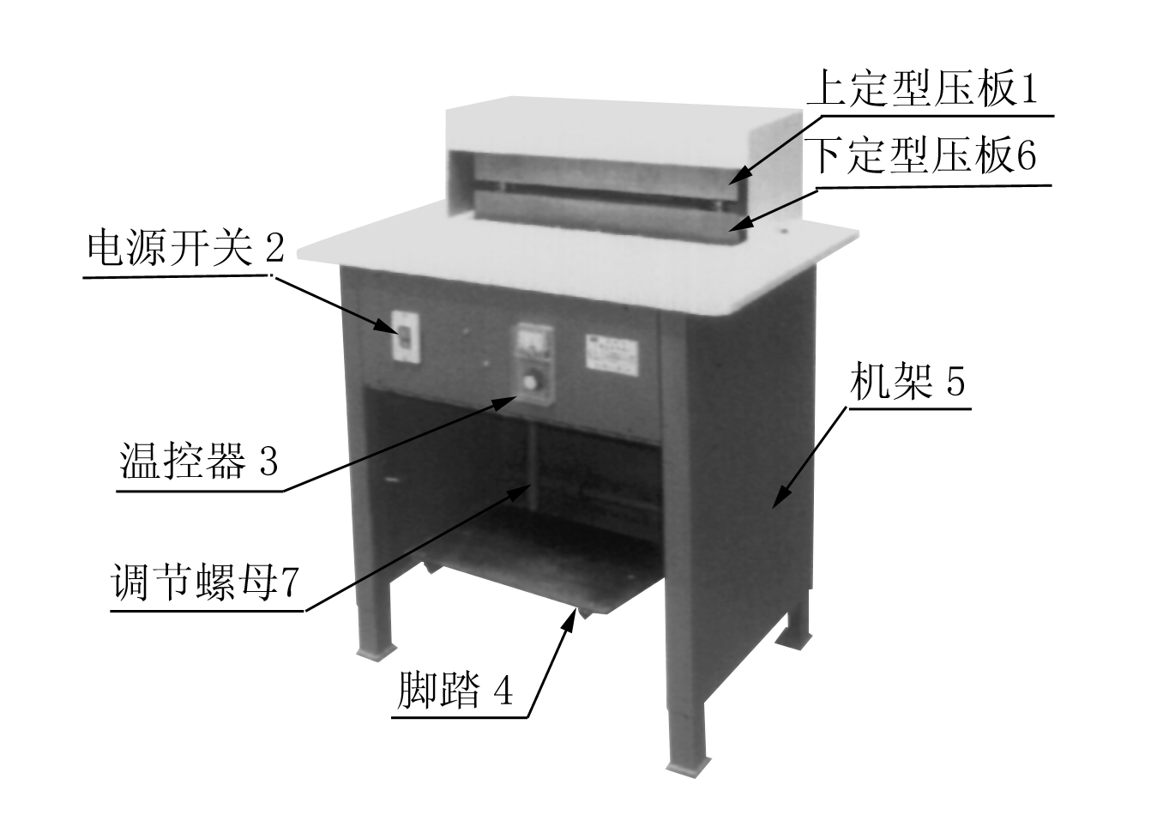

本机由上、下定型压板1、6，温控器3和一组连动的脚踏4装置等部件组成。/This machine is made of up/down forming plates 1 and 6, temperature controller 3, and step switch 4.

- 维护保养/Maintain
- 开机前要检查电源电压和机器电压是否符合。/Check whether the power voltage and the machine voltage are same before use.
- 机器在调整及检修时,请先切断电源,以确保安全。/Please cut off the power before adjustment and checking, make sure safety.
- 机器在停止使用时，请关闭电源，可延长电器的使 用寿命。/Power off when stop the machine.
- 上下压板的导柱部分应经常加注润滑油。/Regularly add lubricant oil.
- 应经常注意保持机器清洁，定期维护，上下定型压板的发热件电源线应定期检查。/Keep the machine clean, make regular maintain and checking.

