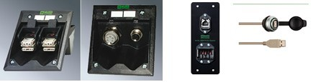

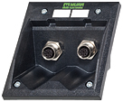

M12, M12 (female/female) B-coded; RS485 (SUB-D9)
Hybrid field-bus couplers MHA-BBE-E - 2 x M12
Art.-No. 67604

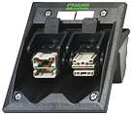

CU, CU (female/male); RS485 (SUB-D9)
Hybrid field-bus couplers MHA-SBE-E
Art.-No. 67605 （详细资料请来电总线）

