深圳市宣德科技有限公司
规格承认书

品名: AC FAN 客户:
DESCRIPTION CUSTOMER

机种: 1725A 料号: 1725HA2BAL
MODEL PART NO

提出日期: 2015-3-4
DATE
制作确认 MADE APPROVE

制作 MADE
检查 CHECKED
核准 APPROVEE
曾平山
魏宝林
魏志成

XUANDEKEJI
电话：0755-21006261
传真：0755-21004795

交流风扇详细说明（如下）
MMULITI-FLOW | 型式  Type | 交流无刷风扇  AC BRUSHLESS FAN | 品名编号  MODEL NO |  | 1725HA2BAL |  | 页数 1  Page
1、机构MECHANICAL
1.1 外观尺寸 EXTERNAL DIMENSION |  |  | 172*150*51
1.2 重量 WEIGHT |  |  | 810 G
1.3安装尺寸 |  |  | 162mm
1.4 轴承BEARING |  |  | BALL
2、电性(在通风及额定电压条件下 IN FREE AIR AT RATED VOLTAGE)
2.1 额定电压 RATED VOLTAGE |  |  | AC 220V
2.2 额定电流 RATED CURRENT |  |  | 0.24A MAXIMUM
2.3 额定功率 RETED INPUT POWER |  |  | 36W MAXIMUM
3. 频率 EFFICIENCY |  |  | 50/60HZ
3.1回转数RATED SPPED (转圈 RANGE) |  |  | 2600 RPM±5%
3.2▲最大风量MAXIMUM AIR FLOW |  |  | 190CFM
3.3▲最大风压MAXIMMSTATIC PRESSURE |  |  | 13 mm/H₂O（AT ZERO AIR FLOW）
4 特性规格 CHARACTERISTIC
4.1电压范围 OPERATIONG VOLTAGE RANGE |  |  | AC 200-240V
4.2 启动电压 STARTING VOLTAGE |  |  | AC 70V MINIMUM
4.3 锁定电流 LOCKED CURRENT |  |  | 0.31A
4.4▲存储湿度OPERATING TEMPERATURE |  |  | - 40°C~+80°C 30%~90%RH
4.5▲环境湿度测试 ENVIRONMENT HUMIDITY |  |  | -40°C~+80°C 30%~90%RH
4.6▲环境湿度测试ENVIRONMENT HUMIDITY |  |  | 10%(RH)45°C FOR 24HRS &98%(RH)45°C FOR 24 HRS
4.7正常动转温度 TEMPERATURE RISE IN NORMAL  OPERATTON |  |  | 本体温最低于70°C  TEMP RISE LESS THAN 35°C ON SURFACE  线圈温升低于50°C  TEMP RISE LESS THAN 25°C ON COLL
4.8绝缘阻抗强度 INSULATION RESISTANCE |  |  | 在本体与绝缘导线间加1500V直流电压之绝缘阻抗10m AT 1500VDC BETWEEN HOUSEING AND BOTH LEAD WIRES
4.9绝缘耐压强度DLELECTRIC STRENGTH |  |  | 必须能抵抗在本体与两条导线间加1500v交流电压3秒0.5mA WTTHSTAND 1500VAC 1 MINUTE 1mA BETWEEN HOUSING AND BOTH LEAD WIRES
4.10▲振动测试 VIBRATION TEST1 |  |  | OK（请参考附件，REFER TO ATACHMENT）
4.11周期寿命LIFE EXPECTANCE （寿命测试方法请参考“11-3”REFER TO “11-3”FOR MTBF TEST DETAIL） |  |  | 在额定电压及正常温湿度条件下可以连续转20000小时CONTINUOUS OPERATION FOR ABORT AT RATED VOLTAGE AND NORMAL TEMPERTATURE & HUMIDITY
4.12温度预期寿命 TEMPERTURE EXPECTANCE LIFE （需命测试方法同“6-12”，THE METHOD OF LIFE EXPECTANCE TEST IS THE SAMEWITH “6-12”） |  |  | 轴承型式  BEARING TYPE | 环境湿度AMBIENT TEMP |  | 预期寿命  EXPECTANCE
 |  |  | 含油铜轴承  SLEEVE BEARING |  |  | 10000小时
 |  |  | 滚珠轴承  BAL BEARING |  |  | 20000小时
4.13绝缘抗拉强度  TENSIBLE STRENGTH OF LEAD WIRE |  |  | 每条线以1公斤的拉力拉扯15秒不会断裂  NOT BROKEN AT 1KG FOR 15 SECPER PIECE
4.14▲噪音分贝SOUND LEVEL |  |  | 48dB/53dB

MULITI-FOW | 型式  TYPE | 交流无刷风扇  AC BRUSHLESS FAN | 品名编号  MODEL NO | 1725HA2BAL | 页数 2  PAGE

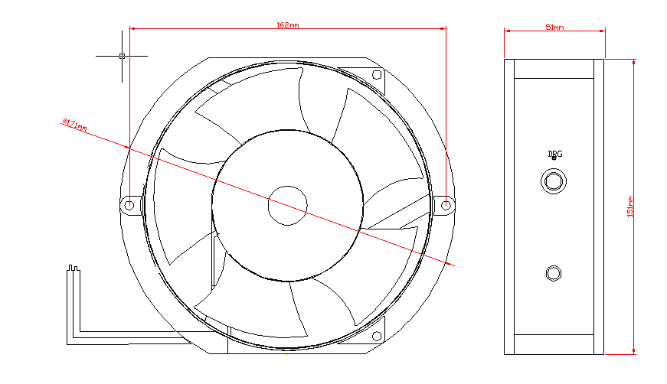

MULITI-FOW | 型式  TYPE | 交流无刷风扇  AC BRUSHLESS FAN | 品名编号  MODEL NO | 1725HA2BAL | 页数 3  PAGE
4-15-1噪音测试说明 SOUND LEVEL TEST DESCRIPTION
悬 吊
SUSPENSION
以额定电压在噪音实验中测试
背景噪音 17分贝
通风状态
(对准风扇中心)
AT READ VOLTAGE IN SOUND PROOF ROOM
(AIM IOCENTER OF THE FAN)
BACKGROUND NOISE 17.0 DBA MAXIMUM
风扇 FAN
1m
麦克风感应器
MIC SENSOR
4-16 特性定义 CHARACTERISTIC DEFINTTION:
4-16-1 起动电压是指当突然通电后能够使风扇起动之最低电压：
START VOLTAGE IS THE IS TEAST VOLTAGE THAT ENABLE TO START THE FAN BY SUDDENT POWER ON
4-16-2输入功率:输入功率在持续旋转3分钟后测量 (INPUT POWER:INPUT POWER SHLL BE MEASURED AFTER 3 MINUTES OF CONTINUOS ROTATION AT RATED VOLAGE.)
4-16-3锁定电流:可以锁机的风扇,锁定电流在清新空气中锁机3分钟测定 (THE FAN CAN BE LOCKED,LOCKED ROTOR CURRENT:LOCKED CURRENT SHALL BE MEASURED WITHIN ONE MINUTE OF ROTOR LOCKED AFTER 3MINUTES OF CONTINUOUS AT RATED VOLTAGE IN CLEAN AIR).

5-1 保护试验(PROTECTION)
几个风扇扇叶连在一起固定限制其旋转,如果风扇及组件不会损坏,限制旋转的组件被解松则风扇可自动重新启动旋转。
（ALL FANS HAVE INTEGRATED PROTECTION AGAINST LOCKED ROTOR CONDITION SO THAT THERE WILL BE NO DAMAGE TO WINDING OR ANY ELECTRONIC COMPONENT .RESTARTING WAS AUTOMATIC NORMAL AS SOON AS AND PROVED THAT THIS FAN IS GOOD FAN）

MULITI-FOW |  | 型号  TYPE | 交流无刷风扇  AC BRUSHLESS FAN |  | 品名编号  MODEL NO |  | 1725HA2BAL |  | 页数4  PAGE
项次 | 主要元件  M/UOR COMPONENTS |  |  | 材货或型式  MATERLAL&SPEC |  | 等级  GRADE |  | 备注
7-1 | 扇框  FAN HOUSING |  |  | 铝框
7-2 | 扇叶  FAN BLADE |  |  | 五片叶 |  | 94V-O
7-3 | 轴心  STATOR CODE |  |  | 铜
7-4 | 轴承  BEARING |  |  | 滚珠
7-5 | 矽钢片  SILICON STEEL STRIP |  |  | H23
7.6 | 漆包铜线  ENAMELED COPPER  WIRES |  |  | FULL DLAMETER |  | UEW  2UWE
7.7 | 印刷线路板  PRINTED WIRING ROARD |  |  | WIRING PRINTED  DOUBLELAYER BORD
7.8 | 引导线  LEAD WIRES |  |  | 聚乙烯氧化物包铜线  POLYVINYL CHLORLDE  ENAMELED COPPER  WIRES(AWG=24) |  | 94-VO
7.10 | 贴纸  LABEL |  |  | 多元脂  PLLYESTER

