FN系列气动交流滚焊机
FN Series Pneumatic AC Rolling Seam Welding Machine
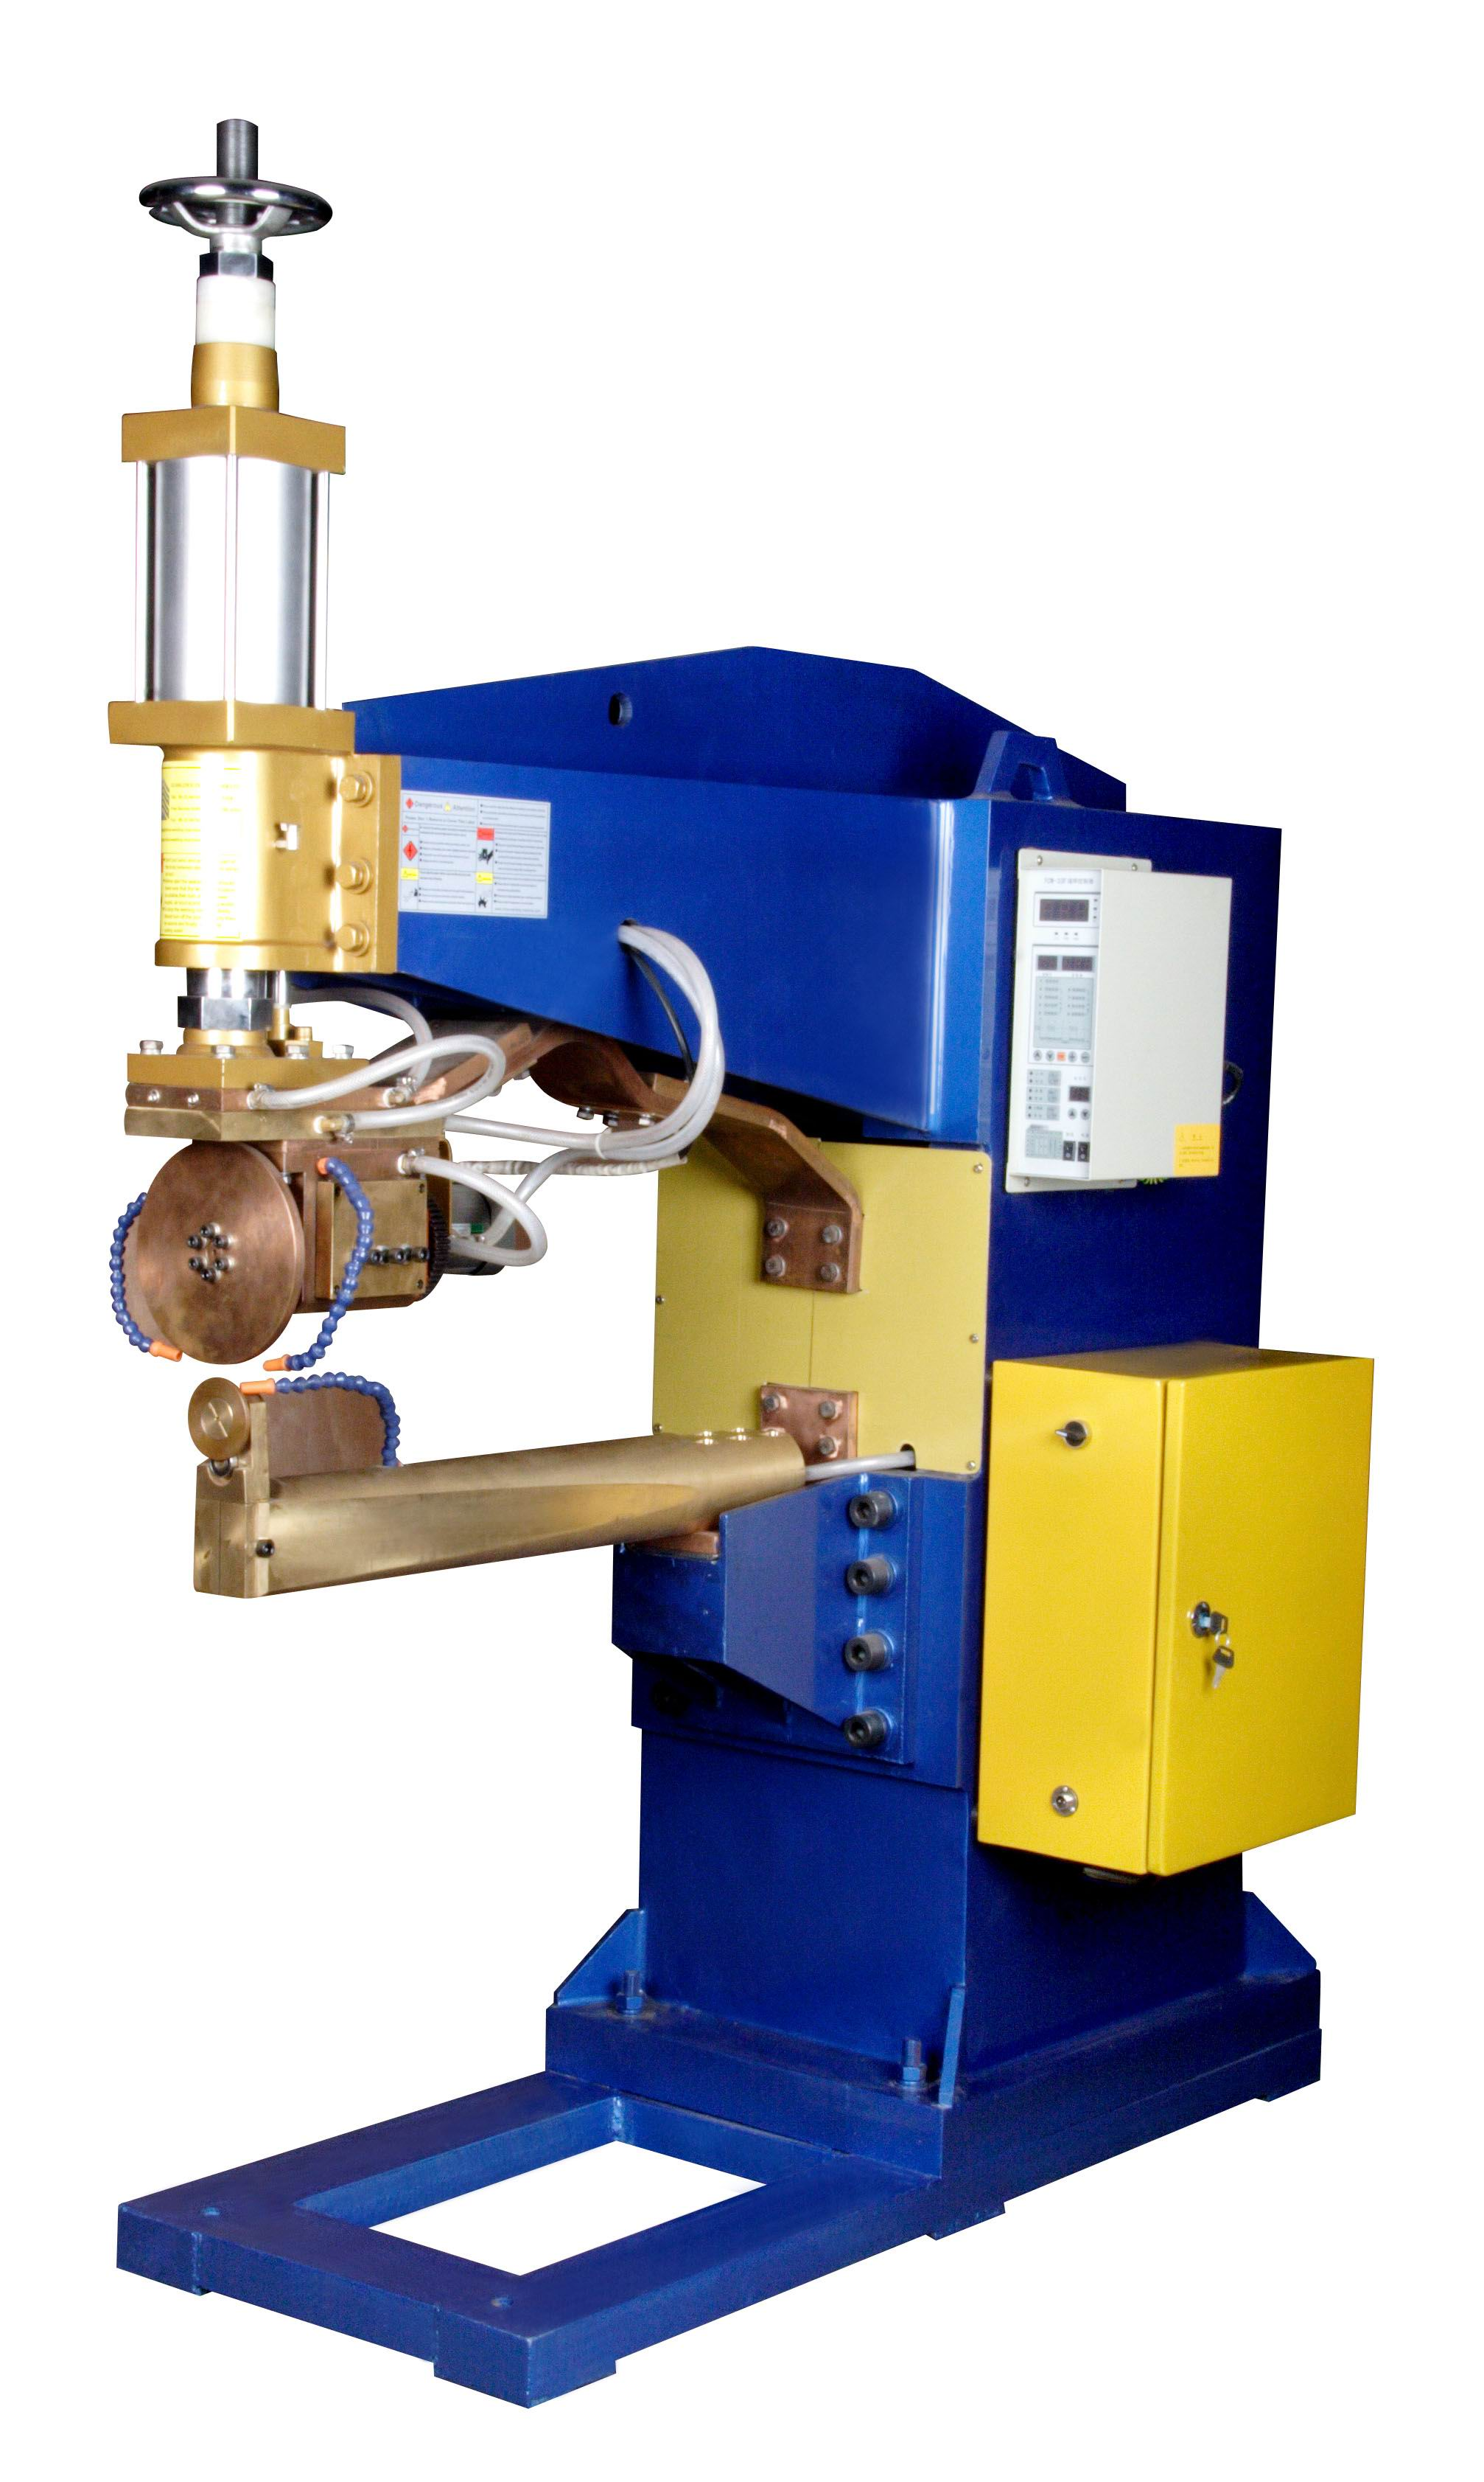
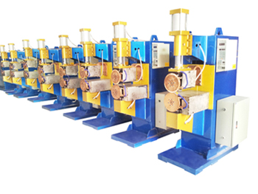
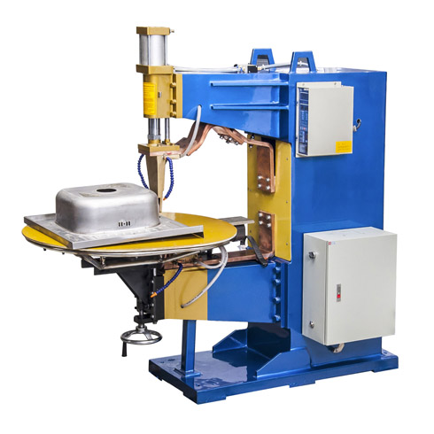
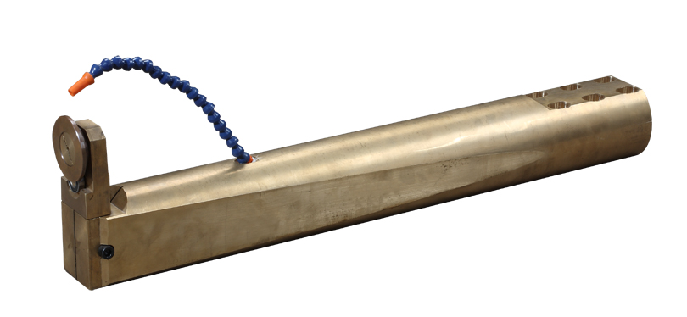

+
=

（加长臂纵缝滚焊机+下电极臂＝加长臂横缝滚焊机）
横纵两用滚焊机

整机特点
FN系列气动交流滚焊机
- 包含两种基本的类型：横缝焊接和纵缝焊接。
- 一台机器可以同时具备横缝焊接和纵缝焊接两种功能，只要将转换一下上电极轮的方向和更换一下下电极臂，就可以在几分钟内完成两种焊接方式的切换。
- 单轮驱动，保证上下两轮切线速度一致。
- 广泛应用于五金、家电、汽车、摩托车油箱、制盆、制罐等金属制造和加工行业。
Features of the Machine
FN Series Pneumatic AC Rolling Seam Welding Machine
- There is two standard models: Transversal Seam Welding Model and Longitudinal Seam Welding Model.
- Also one machine can be used as both transversal seam welding and longitudinal seam welding, only need to change the direction of upper seam wheel head and change the lower welding head and welding arm within minutes.
- Driven one head and free the other head. The two seam wheels have the same tangential speed.
- Widely used in hardware, appliances, automotive, manufacturing pots, can, fuel tank, tank producing and other metal manufacturing and processing industries.
主要技术参数 Main Technical Parameter
项目  Item  型号  Model | 额定  容量 | 额定初  级电压 | 额定  频率 | 最大短  路电流 | 电极  行程 | 焊接  速度 | 电极  压力 | 电动机  电源 | 电动机  功率 | 冷却  水流量 | 重量
项目  Item  型号  Model | Rated  Capacity | Rated  Primary  Voltage | Rated  Frequency | Maximum  Short  Current | Electrode  Stroke | Welding  Speed | Electrode  Pressure | Motor  Power  Source | Motor  Power | Cooling  Water Flow | Weight
项目  Item  型号  Model | KVA | V | Hz | A | mm | M/min | KN | V | W | L/min | Kg
FN-50 | 50 | 380 | 50/60 | 16000 | 50 | 0.6-4 | 2.5 | 3-380V | 90 | 30 | 500
FN-75 | 75 | 380 | 50/60 | 19000 | 50 | 0.6-4 | 3.9 | 3-380V | 150 | 30 | 650
FN-100 | 100 | 380 | 50/60 | 22000 | 50 | 0.6-4 | 4.7 | 3-380V | 150 | 30 | 880
FN-150 | 150 | 380 | 50/60 | 29000 | 50 | 0.6-4 | 6.1 | 3-380V | 150 | 30 | 1050
FN-200 | 200 | 380 | 50/60 | 35000 | 50 | 0.6-4 | 6.1 | 3-380V | 150 | 30 | 1250

标准横缝焊接机
Standard Transversal Seam Welding Machine

散热器专用焊接机
Radiator Rolling Seam Welding Machine

(Longitudinal Direction Seam Welding Machine+Changeable Lower Seam Welding Arm＝Long Arm Transversal Seam Welding Machine)
Both Tansversal and Longitudinal Direction Seam Welding Machine

