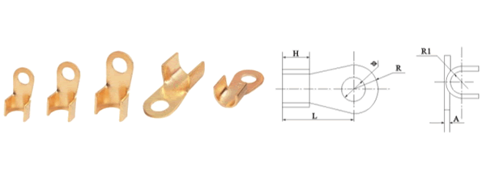
●规格及技术参数Specification
型号Type | 主要尺寸Dimensions(mm)
型号Type | φ | H | L | R | R1 | A
OT-10A | 5.2 | 6 | 14.5 | 4.5 | 2 | 0.8
OT-20A | 6.2 | 7 | 17 | 5.5 | 2.5 | 1
OT-30A | 6.2 | 8.2 | 19 | 5.8 | 3.2 | 1.2
OT-40A | 6.2 | 9 | 19.5 | 6.2 | 3.5 | 1.2
OT-50A | 6.2 | 9 | 23 | 6.5 | 3.5 | 1.2
OT-60A | 8.2 | 10 | 24 | 7 | 4 | 1.4
OT-80A | 8.2 | 11 | 25 | 8 | 4.5 | 1.5
OT-100A | 8.2 | 12 | 29 | 8.5 | 5 | 1.5
OT-150A | 10.2 | 12 | 31 | 9 | 5.5 | 1.6
OT-200A | 10.2 | 14 | 33 | 10 | 6 | 1.7
OT-250A | 10.2 | 15.5 | 36 | 10.5 | 6.5 | 2
OT-300A | 12.2 | 16 | 40 | 11.5 | 7 | 2
OT-400A | 14.2 | 18 | 43 | 13 | 8 | 2.2
OT-500A | 14.2 | 20 | 46 | 14.5 | 8.5 | 2.4
OT-600A | 16.2 | 22 | 50.5 | 16 | 10.5 | 2.8
OT-800A | 18.2 | 26 | 61 | 17.5 | 12.5 | 3.2
OT-1000A | 18.2 | 33 | 66 | 20.5 | 15.5 | 3.8

