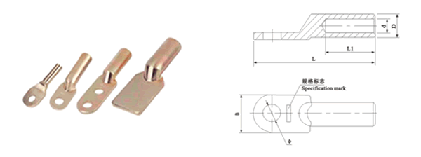
●规格及技术参数Specification
型号  Type | 主要尺寸Dimensions(mm)
型号  Type | φ | D | d | L | L1 | B
DT-10 | 8.5 | 9 | 5.5 | 67 | 31 | 16
DT-16 | 8.5 | 10 | 6 | 67 | 31 | 16
DT-25 | 8.5 | 11 | 7 | 80 | 34 | 18
DT-35 | 10.5 | 12 | 8.5 | 79 | 36 | 20.5
DT-50 | 10.5 | 14 | 9.5 | 87 | 40 | 23
DT-70 | 12.5 | 16 | 11.5 | 95 | 42 | 26
DT-95 | 12.5 | 18 | 13.5 | 105 | 46 | 28
DT-120 | 14.5 | 20 | 15 | 112 | 48 | 30
DT-150 | 14.5 | 22 | 16.5 | 118 | 52 | 34
DT-185 | 16.5 | 25 | 18.5 | 125 | 55 | 37
DT-240 | 16.5 | 27 | 21 | 136 | 60 | 40
DT-300 | 21 | 30 | 23 | 160 | 65 | 45
DT-400 | 21 | 34 | 26 | 165 | 70 | 50
DT-500 | 21 | 38 | 29 | 190 | 75 | 60
DT-630 |  | 45 | 34 | 220 | 85 | 80
DT-800 |  | 50 | 38 | 260 | 85 | 100

