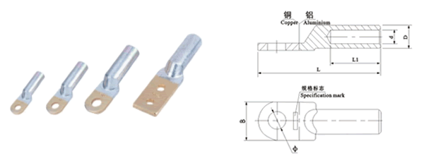
●规格及技术参数Specification
型号  Type | 主要尺寸Dimensions(mm)
型号  Type | φ | D | d | L | L1 | B
DTL-1-16 | 8.5 | 10 | 6 | 70 | 32 | 16
DTL-1-25 | 8.5 | 12 | 7 | 75 | 34 | 18
DTL-1-35 | 10.5 | 14 | 8.5 | 85 | 40 | 20.5
DTL-1-50 | 10.5 | 16 | 9.5 | 90 | 42 | 23
DTL-1-70 | 12.5 | 18 | 11.5 | 102 | 47 | 26
DTL-1-95 | 12.5 | 21 | 13.5 | 112 | 50 | 28
DTL-1-120 | 14.5 | 23 | 15 | 120 | 53 | 30
DTL-1-150 | 14.5 | 25 | 16.5 | 126 | 55 | 34
DTL-1-185 | 16.5 | 27 | 18.5 | 133 | 58 | 37
DTL-1-240 | 16.5 | 30 | 21 | 140 | 60 | 40
DTL-1-300 | 21 | 34 | 23 | 165 | 65 | 45
DTL-1-400 | 21 | 38 | 26 | 170 | 70 | 50
DTL-1-500 | 21 | 42 | 29 | 190 | 75 | 60
DTL-1-630 |  | 54 | 34 | 225 | 80 | 80
DTL-1-800 |  | 60 | 38 | 270 | 90 | 100

