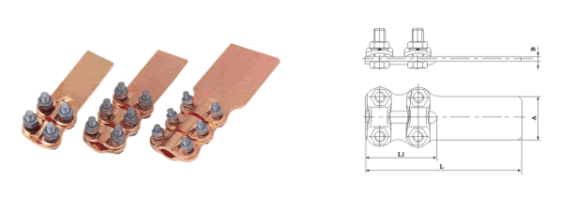
●规格及技术参数Specification
型号  Type | 适用导线  Conductor mm² | 主要尺寸 Dimensions(mm)
型号  Type | 适用导线  Conductor mm² | A | B | L₁ | L₂
ST-1(单孔)Single hole | 35-50 | 40 | 4.5 | 65 | 120
ST-2(单孔)Single hole | 70-95 | 40 | 4.5 | 80 | 136
ST-3(双孔)double hole | 35-50 | 40 | 4.5 | 65 | 145
ST-4(双孔) double hole | 70-95 | 40 | 4.5 | 80 | 175
ST-5(双孔) double hole | 120-150 | 50 | 5.3 | 125 | 225
ST-6(双孔) double hole | 185-240 | 50 | 5.3 | 125 | 225
ST-7(四孔)four hole | 120-150 | 80 | 5.3 | 125 | 239
ST-8四孔) four hole | 185-240 | 80 | 5.3 | 125 | 239

