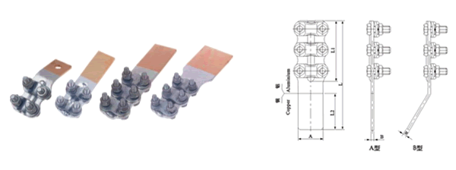
●规格及技术参数Specification
型号  Type | 适用导线  Conductor external  ciameter(mm) | 螺栓  个数  Number  of bolt | 主要尺寸Dimensions(mm)
型号  Type | 适用导线  Conductor external  ciameter(mm) | 螺栓  个数  Number  of bolt | A | B | L | L₁ | L₂
SLG-1A/1B | 8.40-9.60 | 4 | 40 | 5 | 145 | 65 | 65
SLG-2A/2B | 11.00-13.68 | 4 | 40 | 5 | 175 | 80 | 80
SLG-3A/3B | 15.20-16.72 | 6 | 50 | 6 | 225 | 125 | 85
SLG-4A/4B | 19.02-21.28 | 6 | 50 | 6 | 225 | 125 | 85

