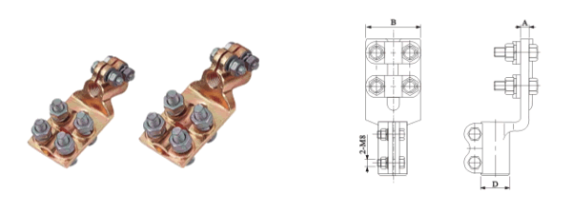
●规格及技术参数Specification
型号  Type | 适用导杆螺纹  Applecable guide bar head(mm) | 主要尺寸Dimensions(mm)
型号  Type | 适用导杆螺纹  Applecable guide bar head(mm) | D | M | A | B
SBT-M12(A) | 12 | 22 | 12 | 6.5 | 50
SBT-M14(A) | 14 | 26 | 14 | 6.5 | 50
SBT-M16(A) | 16 | 26 | 16 | 6.5 | 50
SBT-M18(A) | 18 | 29 | 18 | 7.5 | 60
SBT-M20(A) | 20 | 31 | 20 | 7.5 | 60

