BE72B INSTRUCTION MANUAL V2.0 JAN 2010

BE72B
Bernini Design srl ITALY s subject to change without notice.
Bernini Design assumes no responsibility for any errors that may appear in this

1.0 Description:
instruction manual or in the wiring
diagram. For more information contact us by fax 0755-27153030) or by mail:
BE72B Specifications
DC Supply, Battery Plant | 5V up to 36 Vdc
Static Outputs (short circuit proof) | 200 mAdc
Key Switch Rating | 30 A (30 secs)/80 A (5 secs)
Dimensions-DIN 96 Size | 72X72X55 (ex switch /key)
Weight | 300 gr
Operating Temperature | -30° C /+70° C
Operating Humidity (non-condensing) | 95%

www.wellfut.com

The BE72B includes the basic safeguards to protect an engine. The BE72B features 7
LEDs, 3 Static Outputs and a 30A Key Switch. The BE72B monitors an Oil Pressure-switch, Temperature-switch, Fuel Level-switch, Charger Alternator Voltage and an Emergency-switch. The BE72B provides a MANUAL operating mode, by means of a 30A Key- switch.

WARNING!! High voltage may be present inside the BE72B. To avoid electric-shock hazard, operating personnel must not remove the protective cover. Do not disconnect the grounding connection. The BE72B can start the engine at anytime. Do not work on equipment which is controlled by the BE72B. When
servicing the engine, disconnect the battery and battery charger. We recommend that you place warning signs on the equipment indicating the above.

!! W A R N I N G !! Relays and solenoids connected to the BE72B must be suppressed
using flywell diodes or suppression devices as indicated in the wiring diagram.

MANUAL MODE instruction:

A) - Turn the [KEY-switch] clockwise to [PREHEAT] position until the LEDs illuminate.
B) - Wait until the [OIL PRESSURE] and [CHARGER Failure] LEDs illuminate. If the PREHEAT timer is used, the yellow LED [PREHEAT] will illuminate according to the setting of the potentiometer (back setting: 10-60 secs).
C) - As soon as the green [ENGINE RUNNING] LED starts blinking, turn the [KEY-switch] clockwise to
the spring-loaded momentary position. Turn it until the engine starts. The LED will blink for 15 seconds. If you are not able to start the engine within this period, the FAIL to START alarm will energize.
D) - To stop the engine, turn the [KEY-switch] fully counter clockwise.

NOTE1
In order to stop the engine, we recommend that you use a FUEL SOLENOID energized to run. If you use a STOP SOLENOID (energized to Stop), turn the potentiometer on the back fully clockwise (see wiring diagram). The BE72 will provide a 60-second stop cycle for output #8. When using the STOP
solenoid mode, output #8 will not work as an ALARM output.

1

















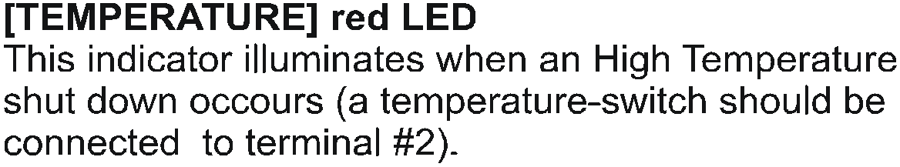

2

