JFB-口/3型三相恒功率并联电热带
JFB · D/3 type Three-phase Constant Wattage Parallel Connection Electric Heating Cable

(1)产品结构与工作原理

Product Structure and Working Principle

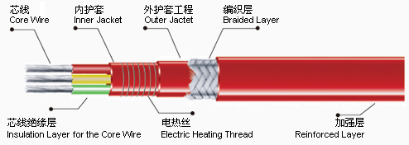
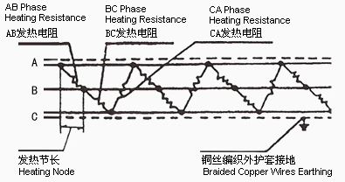

三根平行的绝缘铜线为电源母线，在内护套绝缘层外缠绕电热丝，并将该电热丝每隔一定距离分别依次与三根电源母线循环连接，在每二相间形成连续并联电阻。当母线通以三相电后，各并联电阻同时发热，因而形成一条连续的加热带。

Three parallel insulation copper wires form power generatrix. Electric heating threads are wound around the inner jacket insulation layer ln every certain distance, the heating thread is welded in turn to the three power generatrix circularly. This makes every 2 phases into acontinuous parallel connection resistance. When the generatrix is connected to 3 -phase power supply, the every parallel resistance heats at the same time This makes a continuous heating belt.

(2)产品规格和主要技术特性

Product Types and Main Technical Characteristics

表 2-2： JFB-口/3型电热带主要技术参数表
Table 2-2: Main Technical Parameters of JFB- 口 /3 Type Electric heat cable

型号 | 额定  电压 | 额定  功率 | 绝缘  电阻 | 电气  强度 | 绝缘层  材料 | 产品  最高  耐温 | 防爆  标志 | 最小弯  曲半径 | 介质最  高维持  温度 | 单电源  最大使  用长度
  Type
  Rated Voltage
  (v)
  Rated
  Power
  (w/m)
  Insulation Resistance
  (MΩ /hm)
  Electricity Intensity
  (v/min)
  Insulation Material
  Highest Temp-
  erature
  (℃)
  Explo-
  sion
  Proof Label
  Min.
  Bending
  Radius
  (mm)
  Highest
  Maintenance Temperature of Media
  (℃)
  Max.
  UseLength
  of Single
  Power
  (m)
加强型
Reinforced

JFB-30/3J | 380 | 30 | ≥50 | 2750 | F46 | 200 | ExeIIT4 | 普通型  30  加强型  35 | 120 | 320
  Common
  Reinforced
JFB-40/3J | 380 | 40 |  |  |  |  |  |  | 100 | 240
JFB-50/3J | 380 | 50 |  |  |  |  |  |  | 80 | 190
JFB-60/3J | 380 | 60 |  |  |  |  |  |  | 60 | 160

(3)产品特点及应用场合

Product Characteristics and Applications

三相电热带除有单相电热带相同特点外，还有以下优点：
Besides the above characteristics the three phase heating cables have following advantages:
①率的三相电热带的最大允许使用长度是单相电热带的三倍。
The most tolerable length of the three-phase heat cable is three times longer than the length of the single-phase heating cable of the same wattage.
②三相带截面大，传热导面积大，能提高传输效率。
Bigger section area of three phase heating cable can broaden heat transmitting area and thisincreases the transmitting efficiency.
三相并联带一般适用于大管径，管网系统管线和罐体的伴热保温。
Three phase parallel connection heating cables are suitable forthethermal insulation of pipes with big diameters, pipe lines in nets and tanks.

